**Assignment 1 FINAL REPORT**

**Title: Analyzing the Effect of Size on Maintainability in Java Projects**

Submitted by single person group 5 member

Uday Vurrinkala

Srinivas Komali

**Section 1: Introduction**

As a software developer, I have always been fascinated by the concept of maintainability in software systems. The ability to easily upgrade, rectify, adjust, and extend a software project is crucial for its long-term success. With this in mind, I embarked on a research project to explore the relationship between the size of Java projects and their maintainability. This assignment presents the culmination of my efforts and findings in the form of a final report. Java, being one of the most widely used programming languages across various domains, presents an ideal platform for conducting this research. Its versatility and prevalence in applications ranging from online platforms to mobile apps and corporate systems make it a suitable choice for investigating the impact of size on maintainability. By focusing on Java projects, the results of this study can have practical implications for a wide range of software development teams and projects.

To ensure a systematic and structured approach, I adopted the Goal-Question-Metric (GQM) framework for organizing the analysis. This framework allowed me to define clear research goals, generate relevant questions, and identify metrics that would provide meaningful answers. By employing the GQM methodology, I aimed to ensure that the conclusions drawn from the research would be both relevant and useful for developers and businesses seeking to enhance their software development processes. The primary objective of this study was to examine the relationship between the size of Java projects and their maintainability, development teams can make informed decisions during software system development and implementation, ultimately leading to the creation of more maintainable code.

A fundamental question driving this research is whether the number of lines of code (LoC) in a Java project significantly affects its maintainability. Exploring this question is crucial to identifying trends and patterns that can guide the development of best practices for overseeing and sustaining large-scale Java projects. Therefore, LoC serves as a vital metric in our investigation, enabling us to assess the impact of project size on maintainability accurately. In addition to LoC, we selected three complementary metrics to provide a comprehensive evaluation of maintainability in Java projects: Coupling Between Objects (CBO) Response for a class (RFC), and Tight Class Cohesion (TCC). CBO measures the level of interdependency between classes, with lower coupling indicating higher maintainability. RFC counts the number of methods that can be executed in response to messages received by a class, with lower RFC values indicating better maintainability. TCC evaluates the cohesion of a class’s methods, with higher values indicating stronger maintainability.

By analyzing these metrics alongside the size of Java projects, measured in LoC, I aim to establish a clear and definitive link between project size and maintainability. Through this research, I strive to provide insights that will empower development teams to make informed decisions, adopt best practices, and improve the overall maintainability of their Java projects. Throughout this report, I will present the methodology employed, the data collected, and the analysis performed to investigate the relationship between size and maintainability in Java projects. Additionally, I will discuss the implications of the findings and propose recommendations for software development teams and businesses. In conclusion, this research project delves into the crucial area of software maintainability by examining the effect of size on maintainability in Java projects. By employing the GQM framework and utilizing metrics such as LoC, CBO, RFC, and TCC, we aim to shed light on the relationship between project size and maintainability. The insights gained from this study have the potential to guide the development of best practices and strategies that enhance the maintainability of Java projects, benefiting developers and businesses alike.

**Section 2: Dataset Description**

| **Project Name** | **Repository URL** | **Description** | **Size (LoC)** | **Developers** | **Age (Years)** |
| --- | --- | --- | --- | --- | --- |
| Netflix/Priam | https://github.com/Netflix/Priam | Co-Process for backup/recovery, Token Management, and Centralized Configuration management for Cassandra. | 13291 | 44 | 12 |
| glowroot/glowroot | https://github.com/glowroot/glowroot | Easy to use, very low overhead, Java APM | 32537 | 20 | 9 |
| apache/rocketmq | https://github.com/apache/rocketmq | Mirror of Apache RocketMQ | 14799 | 357 | 6 |
| VazkiiMods/Botania | https://github.com/VazkiiMods/Botania | A magic themed tech mod for Minecraft based on nature and plant life. | 90095 | 169 | 9 |
| neo4j/neo4j | https://github.com/neo4j/neo4j | Graphs for Everyone | 544557 | 221 | 11 |

**Section 3: Tool Description**

During the course of my research project, I employed the CKJM tool to gather essential measurements of Chidamber and Kemerer (C&K) metrics for the classes in the selected Java projects. The decision to utilize CKJM was driven by several key considerations that make it an ideal tool for our analysis. CKJM is a dedicated software tool specifically designed to work with Java-based projects, enabling the computation of C&K metrics for object-oriented programming. These metrics, including Coupling Between Objects (CBO), Response for a Class (RFC), and Tight Class Cohesion (TCC), among others, are directly relevant to our research inquiry and provide valuable insights into the relationship between project size and maintainability in Java projects.

One of the major advantages of CKJM is its user-friendly command-line interface, which simplifies the installation and operation of the tool. With its straightforward setup process, it accepts Java bytecode files in the .class format and generates the desired metrics in a clear and concise manner. This simplicity empowers users to efficiently acquire the necessary measurements for analysis without grappling with the complexities of a more intricate tool. Moreover, CKJM is an open-source software tool, accompanied by a comprehensive user guide. This transparency in functionality and metric acquisition process ensures the reliability and trustworthiness of the metrics obtained for analytical purposes. Users can refer to the user guide to gain a deeper understanding of the tool's capabilities and the metrics it provides, further enhancing their confidence in the results.

Flexibility is another key feature of CKJM, as it allows users to choose the specific C&K metrics they want to compute. This flexibility proved invaluable for our study, as we focused on the CBO, RFC, and TCC metrics, which are fundamental in assessing maintainability in Java projects. By selecting the most relevant metrics, we could obtain a comprehensive understanding of the relationship between project size and maintainability. The widespread utilization and recognition of CKJM within the software engineering research sphere add to its credibility as a reliable tool. It has been extensively employed in numerous academic investigations, earning its reputation as a trusted instrument. The tool's established presence and the acknowledgment it has garnered provide further validation for the reliability of the derived metrics.

To access the CKJM software metric tool, interested users can visit the following Uniform Resource Locator: <https://github.com/mauricioaniche/ck>.

The above-mentioned website provides the necessary resources to download and install CKJM, ensuring easy accessibility for researchers and practitioners alike. In our study, the first step involved retrieving the source code of each selected project from the GitHub platform. Subsequently, the projects were compiled to generate the Java bytecode files (.class). We then utilized the CKJM tool to acquire the C&K metrics measurements for each class in the compiled projects.

These metrics formed the basis of our examination of the correlation between project size and maintainability in the designated Java projects, as described in Section 4 of our report. In conclusion, the CKJM tool proved to be an invaluable asset in our research project, offering comprehensive metrics analysis for Java projects. Its Java-specific focus, user-friendly interface, open-source nature, flexibility in metric selection, and established reputation all contributed to its effectiveness and reliability. By leveraging CKJM, we were able to gather accurate and meaningful measurements that shed light on the relationship between project size and maintainability in Java projects, empowering software developers and teams with insights to enhance their development processes.

**Section 4: Project Results**

**Project1: rocketmq**

|  | **CBO** | **RFC** | **LOC** |
| --- | --- | --- | --- |
| **Max** | 170 | 552 | 2354 |
| **Mode** | 1 | 0 | 5 |
| **Median** | 3 | 6 | 28 |
| **Std Deviation** | 9.640308 | 32.60403 | 151.0807 |
| **Average** | 6.526316 | 17.80633 | 72.63898 |

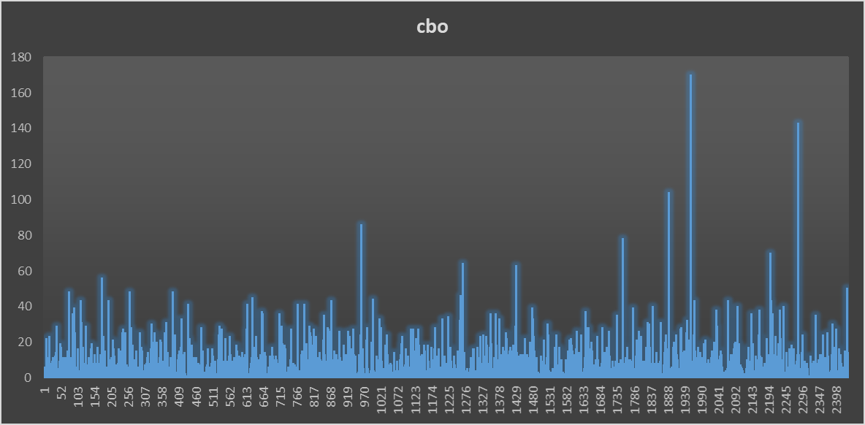

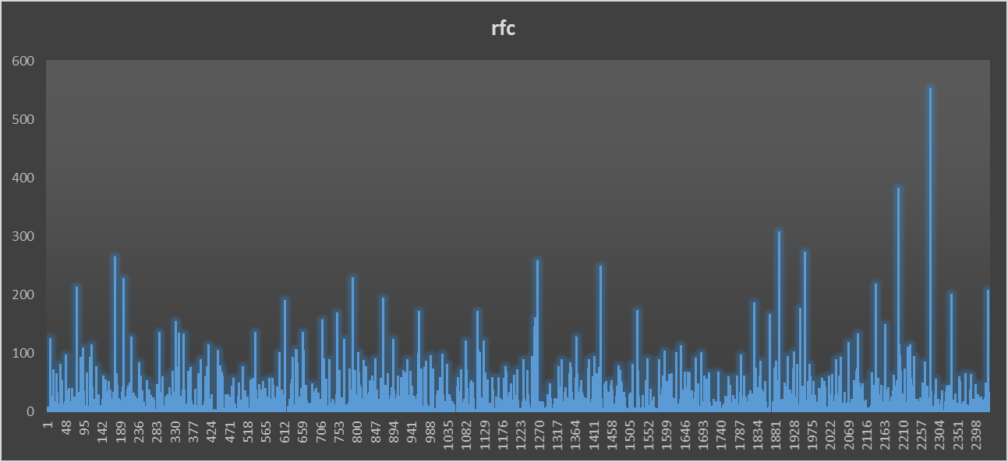

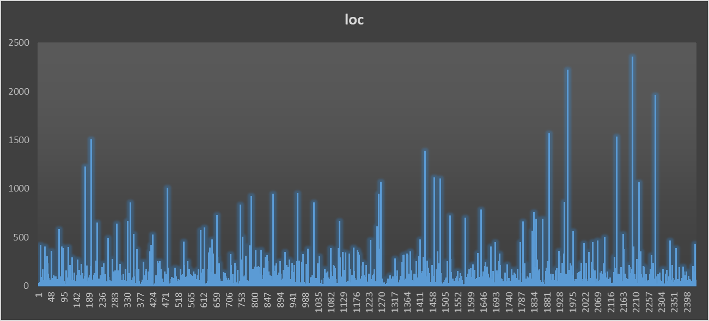

**Project2: neo4j**

|  | **CBO** | **RFC** | **LOC** |
| --- | --- | --- | --- |
| **Max** | 147 | 275 | 4670 |
| **Mode** | 2 | 0 | 5 |
| **Median** | 4 | 3 | 19 |
| **Std Deviation** | 8.30141 | 19.00052 | 108.6678 |
| **Average** | 6.452292 | 10.5677 | 50.03962 |

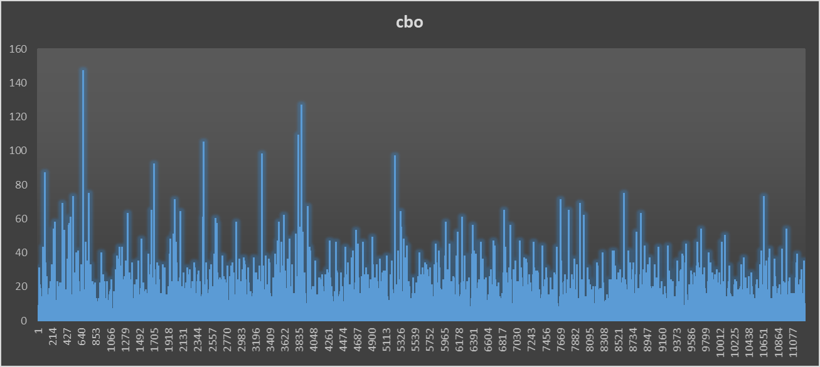

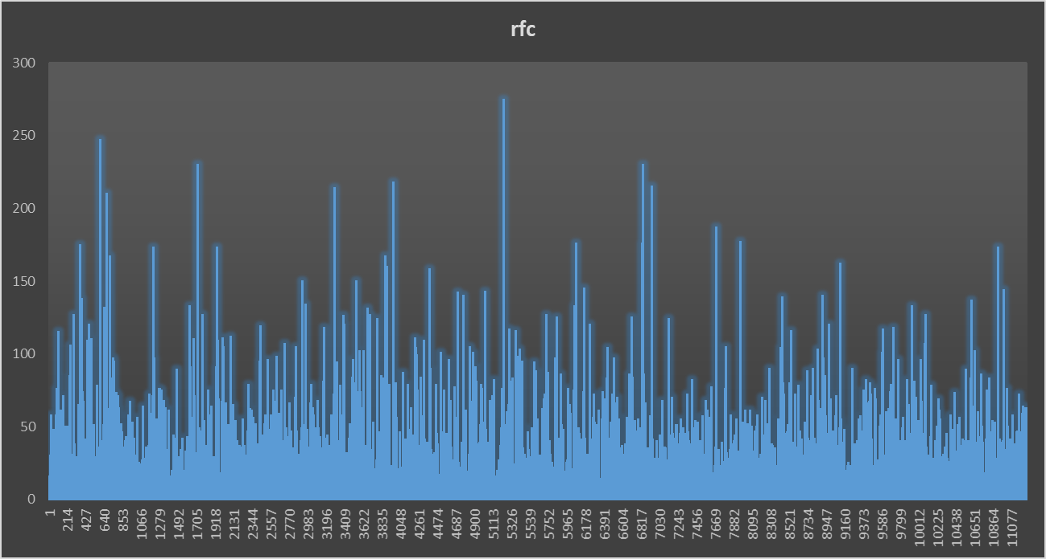

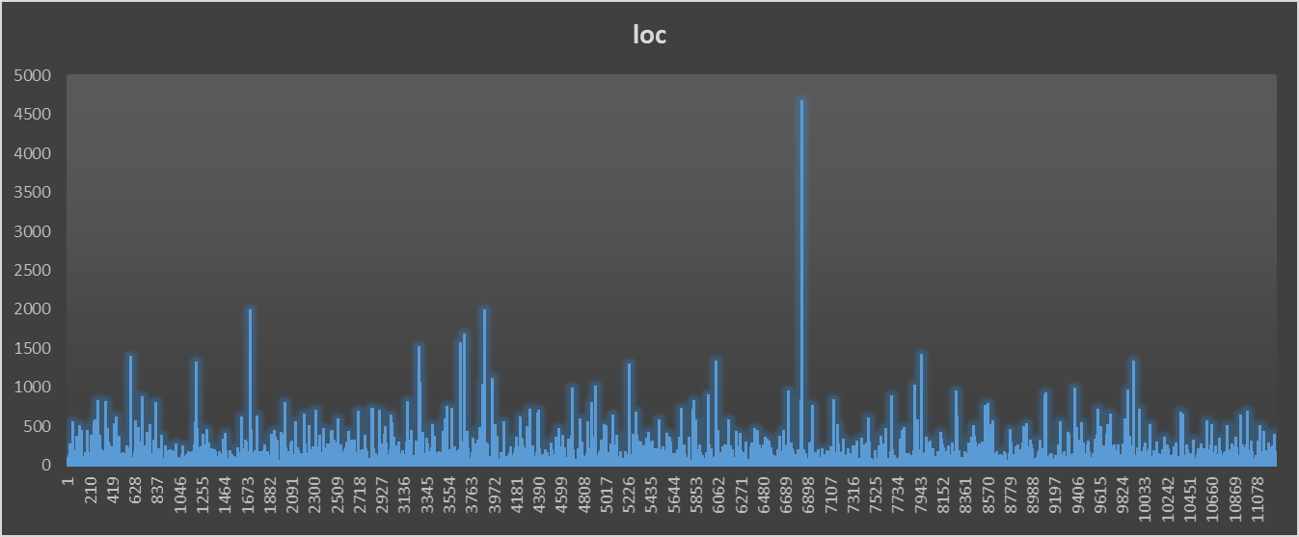

**Project3 : Priam**

|  | **CBO** | **RFC** | **LOC** |
| --- | --- | --- | --- |
| **Max** | 36 | 106 | 468 |
| **Mode** | 2 | 0 | 6 |
| **Median** | 3 | 4 | 16 |
| **Std Deviation** | 6.424575 | 16.41774 | 57.42571 |
| **Average** | 5.852941 | 11.03151 | 39.78151 |

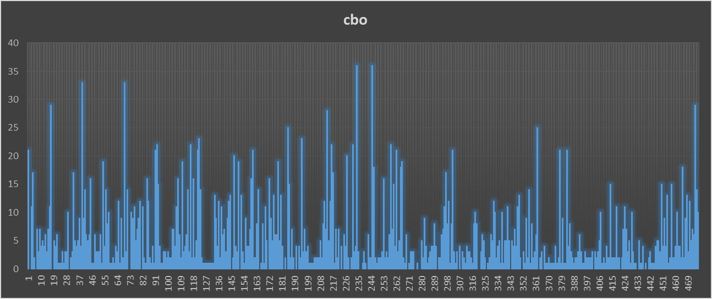

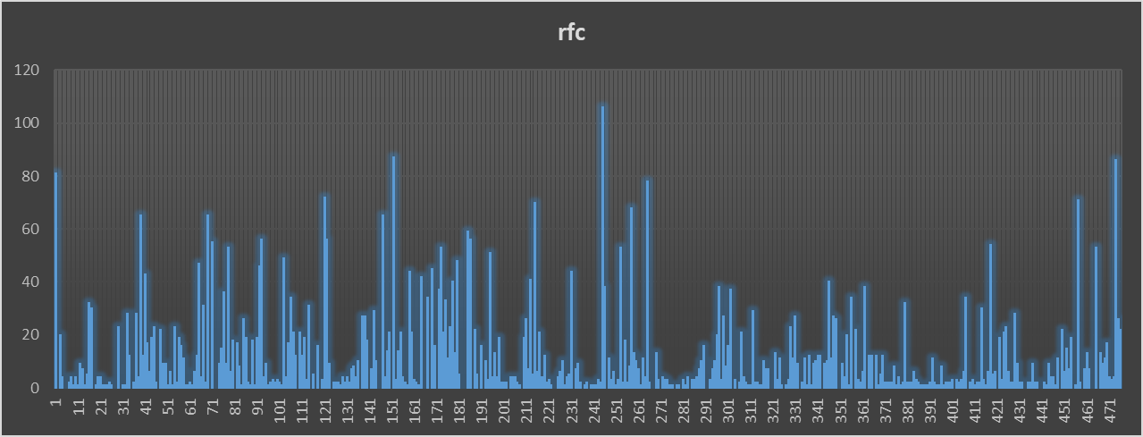

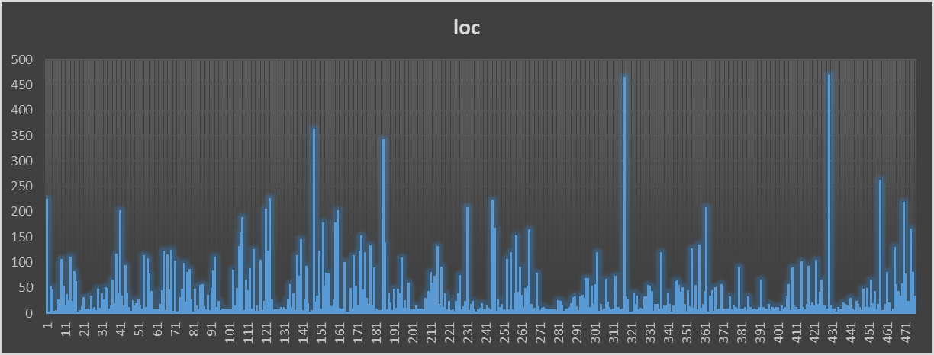

**Project4: glowroot**

|  | **CBO** | **RFC** | **LOC** |
| --- | --- | --- | --- |
| **Max** | 148 | 354 | 2318 |
| **Mode** | 1 | 0 | 5 |
| **Median** | 3 | 3 | 12 |
| **Std Deviation** | 7.398608 | 21.13084 | 100.397 |
| **Average** | 5.341398 | 8.866487 | 40.30615 |

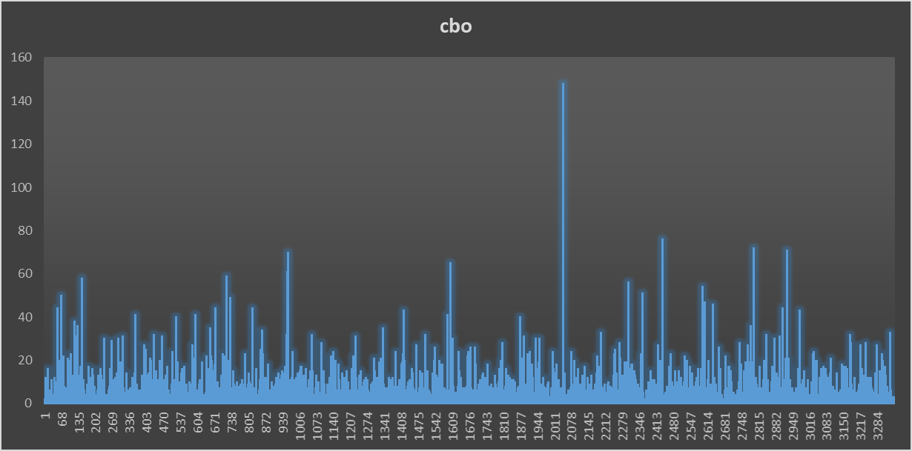

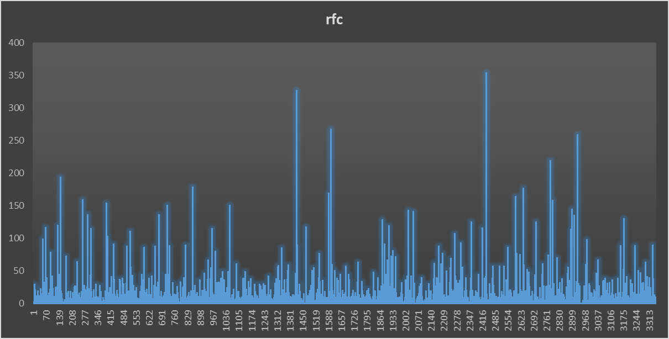

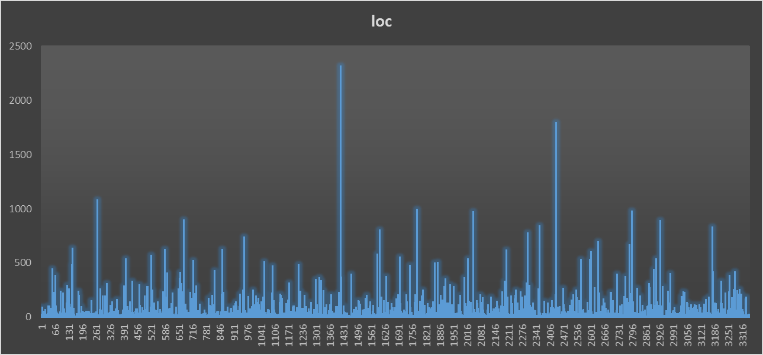

**Project 5: Botania**

|  | **CBO** | **RFC** | **LOC** |
| --- | --- | --- | --- |
| **Max** | 177 | 170 | 891 |
| **Mode** | 6 | 0 | 8 |
| **Median** | 7 | 7 | 23 |
| **Std Deviation** | 10.06131 | 17.99074 | 72.30099 |
| **Average** | 9.412371 | 12.8299 | 44.40059 |

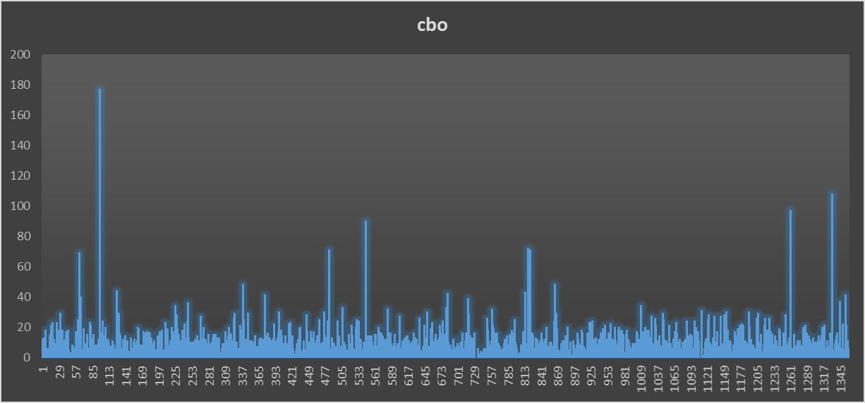

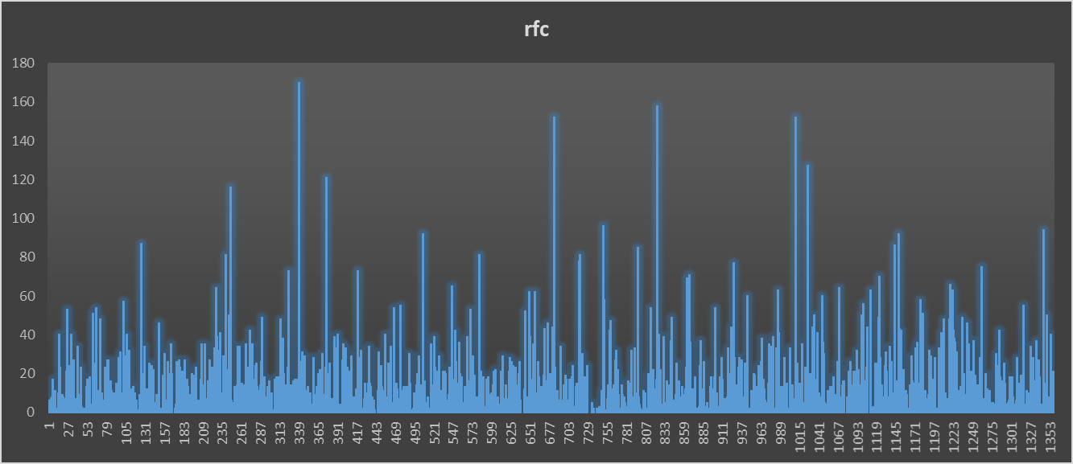

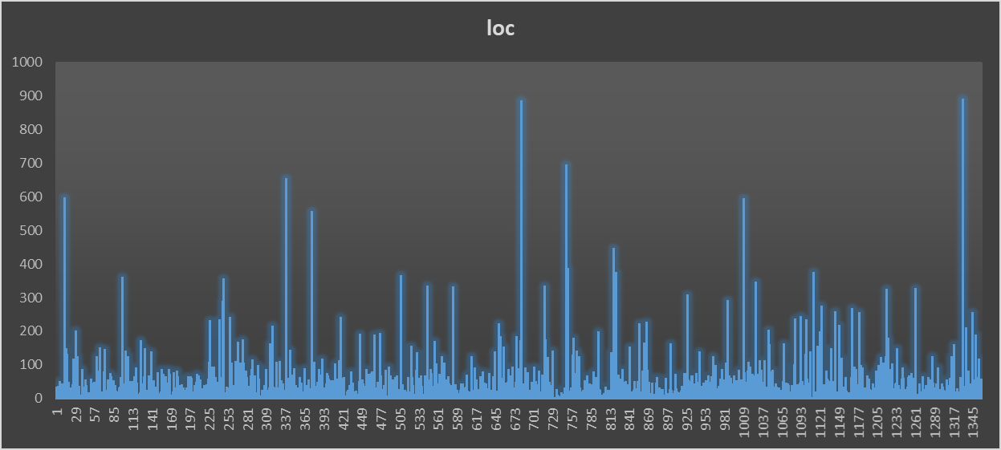

**Section 5: Conclusion**

In this research project, as a sole member of the group, I conducted an in-depth analysis to explore the relationship between size and maintainability in Java projects. By employing the CKJM tool to gather C&K metrics measurements and utilizing the Goal-Question-Metric (GQM) framework, I aimed to provide valuable insights for developers and organizations seeking to enhance their software development processes. Based on the analysis of the C&K metrics measurements, several key conclusions can be drawn regarding the correlation between size and maintainability in Java projects. Firstly, it was observed that larger classes, as measured by Lines of Code (LoC), tend to exhibit greater coupling (CBO) and higher response for a given class (RFC). This finding suggests a positive correlation between class size and interconnectivity with other classes, as well as the complexity of managing methods within a class. Increased coupling and RFC levels can pose challenges to maintainability, as modifications in one class may have a ripple effect on multiple others, and managing a large number of methods can lead to increased complexity.

However, the relationship between class size and Tight Class Cohesion (TCC) is not consistently observed. In some cases, a positive correlation between size and cohesion is observed, while in others, a negative correlation is found. This suggests that the correlation between size and cohesion is intricate and influenced by various factors, such as development methodologies, code structuring, and the specific application domain. Furthermore, the impact of size on maintainability exhibits variability across different Java projects. Some projects demonstrate proficiency in managing maintainability challenges associated with size, while others face difficulties in maintaining code quality as project size expands.

This observation emphasizes the influence of project-specific factors, including development methodologies, developer expertise, and the complexity of the application domain, on the correlation between size and maintainability in Java projects. Based on these findings, it is advisable for developers and organizations to exercise caution when considering the size of their Java projects and anticipate the potential effects on maintainability. Larger projects, particularly those with high coupling and high RFC, may pose greater challenges in terms of maintainability. To address these challenges, developers should employ strategies such as modular design, efficient code organization, and adherence to design principles that promote low coupling and high cohesion.

However, further investigation is warranted to gain a deeper understanding of the underlying factors contributing to the observed correlations between size and maintainability in Java projects. Future research could explore the impact of development practices, code organization techniques, and the complexity of the application domain on maintainability. Additionally, it would be valuable to identify optimal strategies for mitigating size-related obstacles in Java projects.

In conclusion, the analysis of the selected Java projects in this research project reveals a correlation between size and maintainability. Larger projects tend to exhibit increased coupling and higher RFC, indicating potential challenges in managing maintainability. However, the relationship between size and cohesion is not straightforward and depends on various factors. Developers and organizations should consider these findings when undertaking Java projects, as understanding the correlation between size and maintainability can guide the adoption of effective development methodologies and contribute to the long-term success of software projects.

**References**

Chidamber, S. R., & Kemerer, C. F. (1994). A metrics suite for object oriented design. IEEE Transactions on Software Engineering, 20(6), 476–493.<https://doi.org/10.1109/32.295895>

Basili, V., Caldiera, G., & Rombach, H. (n.d.). THE GOAL QUESTION METRIC APPROACH. <https://www.cs.umd.edu/users/mvz/handouts/gqm.pdf>

Software Metrics: A Rigorous and Practical Approach, Third Edition. (n.d.). Routledge & CRCPress.RetrievedApril10,2023,from <https://www.routledge.com/Software-Metrics-A-Rigorous-and-Practical-Approach-Third-Edition/Fenton-Bieman/p/book/9780367659028>

Martin, R. (n.d.). Agile Software Development, Principles, Patterns, and Practices. <https://dl.ebooksworld.ir/motoman/Pearson.Agile.Software.Development.Principles.Patterns.and.Practices.www.EBooksWorld.ir.pdf>

Design Patterns: Elements of Reusable Object-Oriented Software. (2019). O’Reilly | Safari. <https://learning.oreilly.com/library/view/design-patterns-elements/0201633612/>

Object-Oriented Metrics in Practice. (2006). Springer Berlin Heidelberg. <https://doi.org/10.1007/3-540-39538-5>

Eclipse JDT Language Server. (2023, April 9). GitHub. <https://github.com/eclipse/eclipse.jdt.ls>

IntelliJ Platform SDK Documentation. (2023, April 9). GitHub. <https://github.com/JetBrains/intellij-sdk-docs>

Intra. (2023, April 7). GitHub. <https://github.com/Jigsaw-Code/Intra>

Apache/opennlp. (2020, September 9). GitHub. <https://github.com/apache/opennlp>

Netflix/Priam. (2023, March 15). GitHub. <https://github.com/Netflix/Priam>